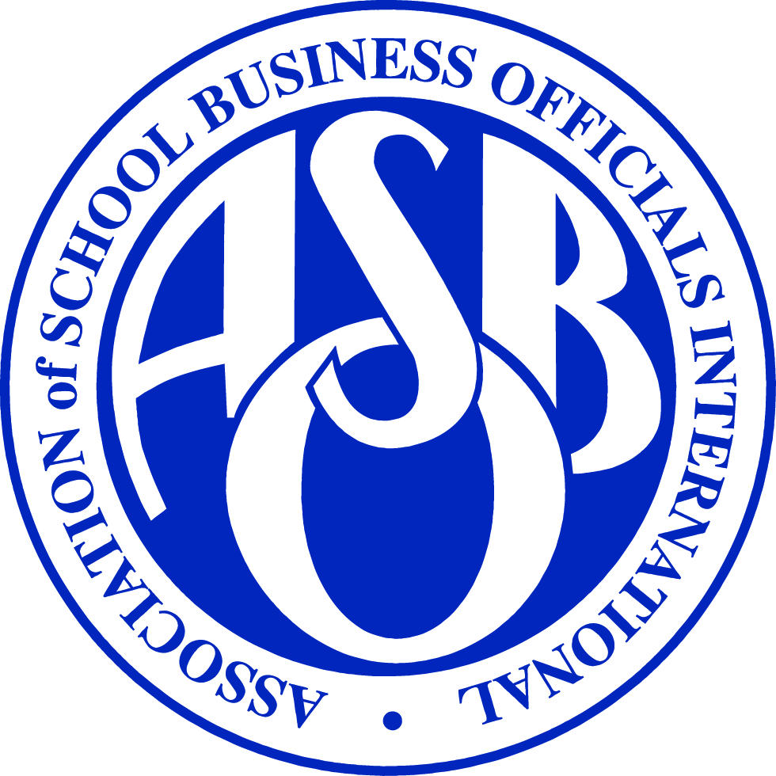
ASBO INTERNATIONAL
SFO Certification: Creating Your Career Pathway
Slide | Script
Slide #1 | ASBO International - SFO Certification: Creating Your Career Pathway
Slide #2 | The impact of the financial crisis has hit families and communities hard through job losses, business closures, and significant cuts to education. Unfortunately, it’s likely more cuts are ahead.
Slide #3 | With revenues declining and costs increasing, students are feeling the financial squeeze both in and out of the classroom.
Slide #4 | In these times of economic uncertainty, leadership is the common denominator of success, and as your professional association, the Association of School Business Officials International (ASBO) offers the educational, leadership, and networking opportunities that will strengthen your leadership skills and help you succeed.
Slide #5 | For more than 100 years, ASBO has been developing school business leaders and setting the standard for excellence in school business management.
Slide #6 | Our membership is a global community of professionals with a broad range of financial management responsibilities who share common values of competence, integrity, professional growth, responsibility, and accountability.
Slide #7 | ASBO works on your behalf to elevate the profession by offering certification known as the Certified Administrator of School Finance and Operations® (SFO®), which defines the essential skills and knowledge that every school business official needs,
Slide #8 | The SFO® program is a way for school business officials to earn recognition for having the knowledge and skills necessary to do their jobs. Not only do you benefit professionally, it also builds public confidence in your school district’s fiscal responsibility. What’s more, SFO certification is acknowledged throughout North America.
Slide #9 | Program development began with a Job Task Analysis Panel that examined the tasks performed by school business officials and the knowledge and skills needed to perform those tasks. To validate the results, ASBO held a focus group meeting and surveyed school business officials. The first 100 school business managers were certified with a beta test program in 2010.
Slide #10 | Certification is an opportunity to measure your knowledge and skills against the professional standard, be recognized for your professional accomplishments, stand out from your peers, and instill public confidence in your school system.
Slide #11 | SFO certificants represent a wide range of demographics and levels of experience.
Slide #12 | SFO certification is granted to professionals who demonstrate eligibility through education and experience, pass a comprehensive two-part exam that tests competency in accounting and school business management topics, and adhere to the ASBO International Certification Code of Conduct. The designation is maintained through annual renewal and a three-year recertification process.
Slide #13 | Applicants pay an application fee, exam fees, and an annual renewal fee. Certification is valid for three years, after which time you must apply to be recertified. There are no additional fees associated with recertification.
Slide #14 | There are no prerequisites to take the SFO Exam Part 1. To take the SFO Exam Part 2 and meet the overall certification requirements, you must have a master’s in a field related to school business management plus two years of experience as a school business official with administrative responsibility in the areas in the exam competencies or have a bachelor’s degree plus three years of experience as a school business official. Professionals who do not meet these requirements but believe they are seasoned practitioners may also apply.
Slide #15 | Depending on your education level, you must have at least 24 or 36 months of overall administrative responsibility in each of these school business related areas….
Slide #16 | and at least 24 or 36 months of administrative experience in at least three of these school-business related areas.
Slide #17 | The exam is divided into two parts. The first part focuses on information that is necessary at the time of job entry, while the second part covers competencies school business professionals learn on the job.
Slide #18 | The first part of the exam addresses information that is necessary at the time of job entry, such as managing accounting systems and managing accounting functions.
Slide #19 | The second part of the exam covers competencies that school business professionals experience on the job, such as conducting financial planning and analysis and budgeting and reporting activities.
Slide #20 | The second part of the exam also covers risk, school facility, and information system management…..
Slide #21 | As well as human resources and ancillary services such as transportation, food services, and purchasing.
Slide #22 | Candidates take the exam at a computer-based testing center through the Pearson VUE network in the United States and parts of Canada.
Slide #23 | Preparing for the exam is primarily through self-study. Resources are available at www.asbointl.org/certification.
Slide #24 | Certificants may use the prestigious SFO after their name. In addition, ASBO promotes their accomplishments by sending a press release to the superintendent, school board, and local press. Certificants also receive a certificate and lapel pin.
Slide #25 | SFO certification must be renewed annually and is valid for three years. To renew, certificants must agree to adhere to the Certification Code of Conduct and pay the annual renewal fee of $125. You can also request to have your credentials published to others, as well as record your contact hours in the online application system.
Slide #26 | Certification is valid for three years. To be recertified, certificants must obtain and document 90 contact hours, ensuring that at least 60 of those contact hours are in a structured learning environment and 30 are in an unstructured learning environment. Certificants have access to a credential management system that helps them keep track of their required contact hours for renewal.
Slide #27 | Begin the application process at the Online SFO Credential Management System.
Slide #28 | Preparing for the SFO exam is primarily through self-study. These sample questions will get you started. Go to www.asbointl.org/certification for more exam preparation materials.
Slide #29 | Start your SFO certification journey today and encourage colleagues in your state/province to do the same at www.asbointl.org/certification.

