SFO® Certification Toolkit: Table of Contents

The SFO® Certification Toolkit prepares you to market the Certified Administrator of School Finance and Operations® (SFO®) program in your state/province and assist candidates in preparing for the exams.
The following materials are included in this Toolkit (printed and/or found on the USB drive):
- Letter from the Certification Commission (printed only)
- Guide to Integrating the SFO Certification into Affiliate Activities (printed and USB drive)
- Affiliate Partnership Discount Program Information (printed and USB drive)
- Marketing Resources
  - Two full-page advertisements (USB drive)
  - SFO Certification article (USB drive)
  - PowerPoint presentation and script (USB drive)
  - Values of the Profession (USB drive)
  - SFO certification brochure (printed and USB drive)
- Test Preparation Materials
  - Guide to Studying for the SFO Examinations (USB drive)

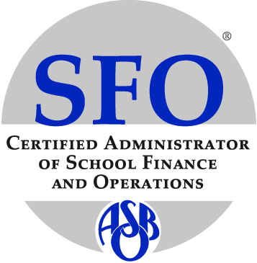

ASBO International's certification program is governed by the Certification Commission, a semi-independent certifying body of the Association of School Business Officials International. In adherence to best practices for certifying bodies, Certification Commission volunteers and certification staff are not involved in the development of any preparatory program, and no preparatory program is endorsed by the Certification Commission nor is a prerequisite to earn the certification. The Certification Commission and its staff are solely responsible for the policies and administration of the certification program, including application procedures and qualification requirements.

Visit www.asbointl.org/certification or contact ASBO staff at certification@asbointl.org for more information.

